EXPERIMENT NO. 1
Flight Reservation System using Zoho Creator (SaaS)

Aim
To design and develop a Flight Reservation System using Zoho Creator for managing passenger booking details and generating reservation reports.

Objective
• Create a reservation form.
• Store passenger details.
• Display records in a report.
• View individual reservation details.

Software Requirements
• Zoho Creator
• Web Browser (Google Chrome)
• Internet Connection

Theory
A Flight Reservation System is a cloud-based application used to collect passenger information, manage flight bookings, and generate reports. Zoho Creator provides low-code tools to create forms, workflows, and reports without extensive programming.

Procedure
1. Log in to Zoho Creator.
2. Create a new application named Flight Reservation System.
3. Create a form with fields such as Passenger Name, Trip Type, From, To, Departure Date, Return Date, Travelers, Class, Fare Type, Flight Type, Mobile Number, and Email.
4. Save the form.
5. Enter sample booking records.
6. Create a report to display all submitted records.
7. Open individual records to verify stored information.
8. Test the application by adding multiple reservations.

Observation
• The form accepted all passenger details successfully.
• Data was stored correctly after submission.
• The report displayed all reservation records in tabular format.
• Individual records showed complete booking information.
• The application worked correctly without errors.

Result
The Flight Reservation System was successfully created using Zoho Creator. Passenger details were stored, retrieved, and displayed correctly through reports.

Conclusion
The experiment demonstrated how a cloud-based SaaS application can be developed using Zoho Creator to automate flight reservation management efficiently.
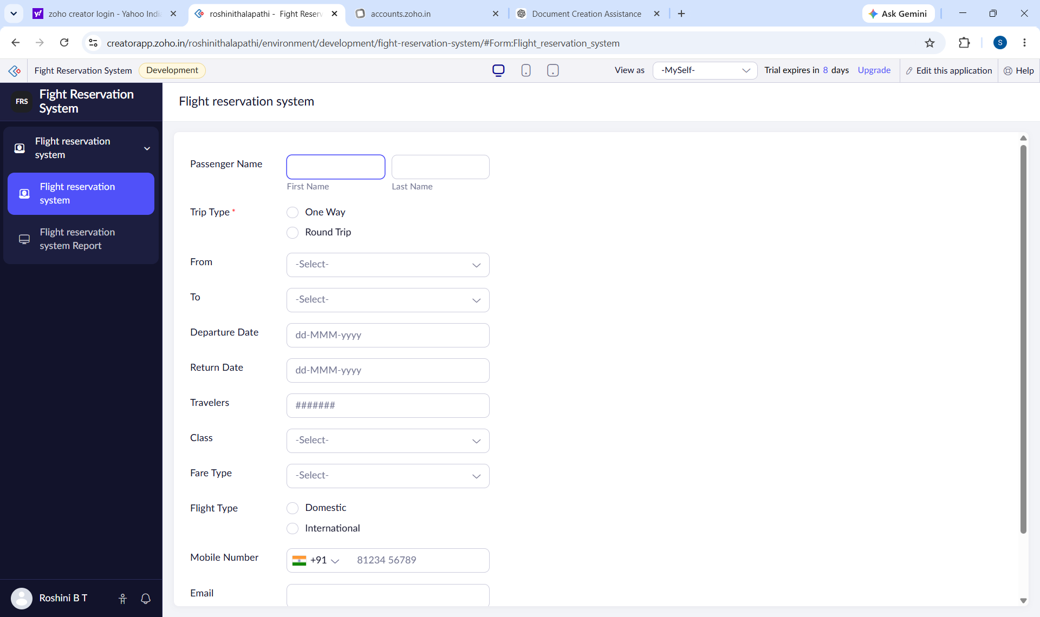
Figure 1: Flight Reservation Form
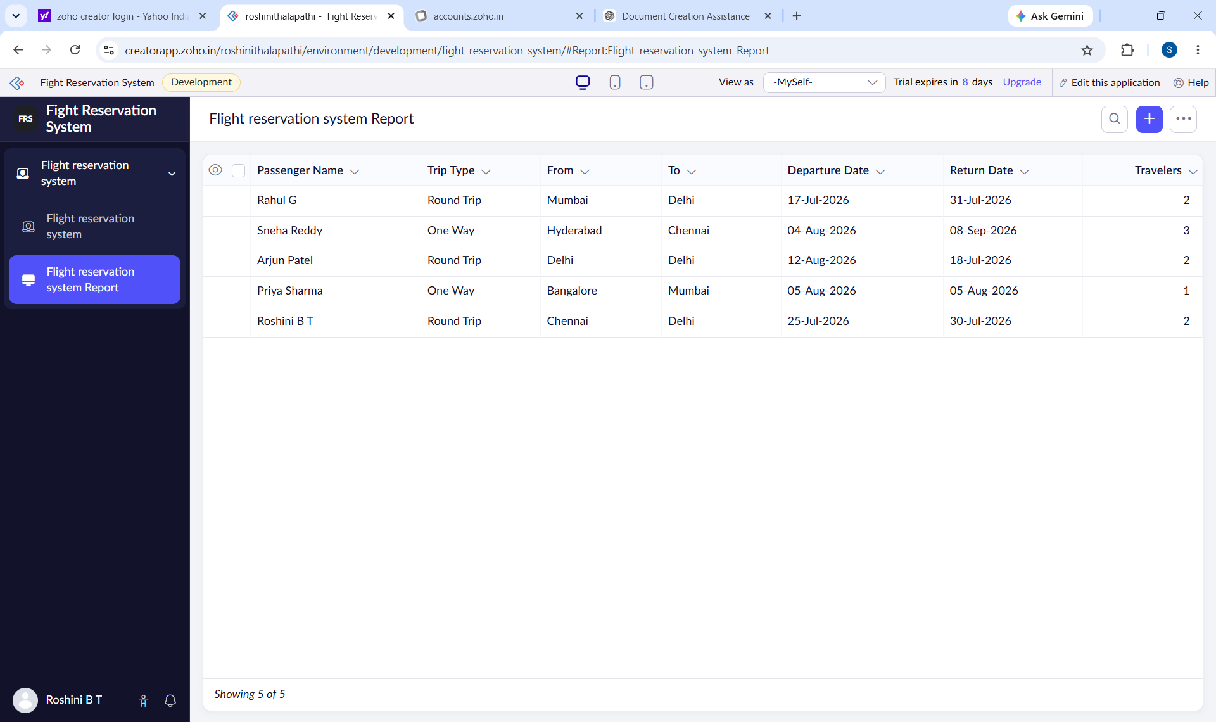
Figure 2: Reservation Report
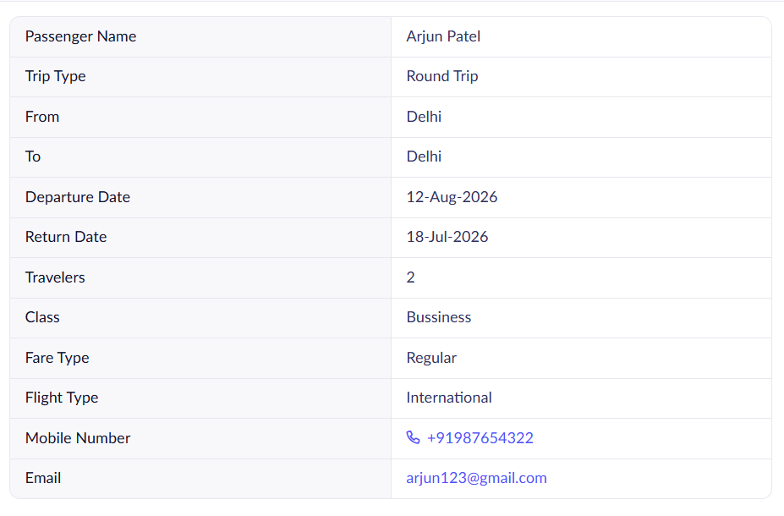
Figure 3: Individual Reservation Record

